**What is Header Bidding and why did it come into place?**

Before `Header Bidding`, Ad space would be auctioned only when the web page with ad placements began to load. So once ad placements begin loading, a request would be sent to the Ad servers. This is also known as the Ad server waterfall model. In this model, once the request goes to the ad server, Direct orders are served first (direct orders = guaranteed impressions for advertisers), after that priority would be given to the Real-time orders.

This approach isn't the best way to consume the ad space because if the ad space doesn't sell in direct orders, it will fall into the real-time bidding category and might cascade down to several ad exchanges, leading to a drop in the price of impressions.

Header bidding is an innovative concept that tries to deal with the drawbacks of the waterfall model. The major difference between the two is that in header bidding is that the auction happens outside the ad server and before page load. When the header of a web page (which has all the metadata: formatting, page, and tracking) loads, the header bidding begins. As the header code begins to load, a bid request is sent to Demand Partners and during a split second window the following is taking place:

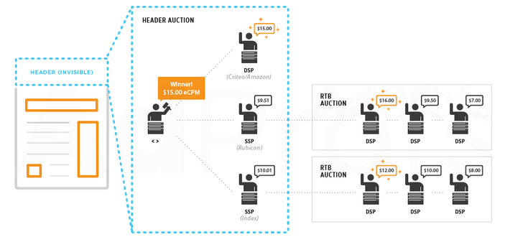

**The benefit to the Buyer**

* Getting a first look at the best impressions.
* Now, this way the advertisers get to see the first look of the EVERY impression available and if they like the impression, they can bid for it.

**The benefit to the Publisher**

The publisher has all the control now. A shift in power if you may. How?

* The publisher can now field bids on every page and prioritize delivering ads even before the direct orders.
* Publishers are able to sell their inventory on best price basis putting all demand partners at the same level.
* Since buyers can now cherry pick impressions, it also has the potential to drive up rates of unsold inventories that would usually be sold at “last look” prices in ad exchanges.

**Challenges to Header Bidding:**

* The infrastructure cost involved in ramping up the server count to handles billions of ad impression for Demand side and Supply side platforms.
* Publishers have to keep a check on the demand partners they choose. Having strong demand partners is the key to making the most revenue out of Header Bidding.

**References**:

* Image credit: <http://adprofs.co/beginners-guide-to-header-bidding/>
* blog.adform.com/products/header-bidding-past-present-and-future-challenges/

----------------------END---------------------